DDoS PROTECTION SYSTEM FOR CLOUD USING AWS AND MACHINE LEARNING

A PROJECT REPORT

*Submitted by*

Charvi Jain [RA2111047010113]

Shaurya Singh Srinet [RA2111032010006] Shounak Chandra [RA2111032010026]

*Under the Guidance of*

Dr. Nagendra Prabhu S.

(Assistant Professor, Department of Computational Intelligence)

*in partial fulfillment of the requirements for the degree of*

BACHELOR OF TECHNOLOGY

in

ARTIFICIAL INTELLIGENCE

&

BACHELOR OF TECHNOLOGY

in

COMPUTER SCIENCE AND ENGINEERING

WITH SPECIALIZATION IN INTERNET OF THINGS

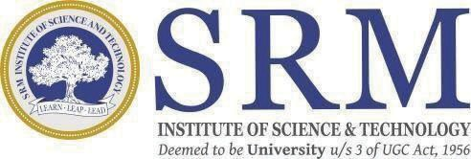

DEPARTMENT OF COMPUTATIONAL INTELLIGENCE

SCHOOL OF COMUPTING

COLLEGE OF ENGINEERING AND TECHNOLOGY

SRM INSTITUTE OF SCIENCE AND TECHNOLOGY KATTANKULATHUR- 603 203

FEB 2025